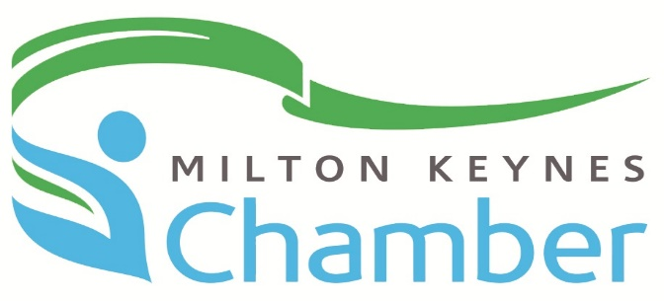

Person Specification

Director
Milton Keynes Chamber of Commerce

Status Non-Executive Director

Elected by Members at the AGM

Term of Office Four years. Maximum of two consecutive terms prior to a one year “fallow field” year of exclusion.

Accountable to Chamber Members and the President of the Board of Directors

Essential Criteria:

- Successful senior manager who has held posts that encompass; operational, functional and strategic responsibilities.

- Genuine commitment to the Chamber network and an employee of a current member of the Milton Keynes Chamber of Commerce.

- Excellent communication skills with strong personal and professional networks

- Drive, commitment, and availability. In terms of both time/availability to be able to fulfil the necessary time commitments and responsibilities as laid down in the Director’s job description.

Collective Criteria:

The Board is representative of the diverse Chamber Members’ activities.

Ideally the Board looks to include members with experience in:

- Commercial, public and not for profit sector
- Manufacturing and services sectors
- Professional services
- Financial services
- SME’s and large corporate
- Private owner/ family managed
- Businesses that have domestic orientation and businesses that have exploited International markets

The Board also diversifies with its functional and professional experience and looks to include:

- General management
- Accounting/audit/financial management
- HR
- IT
- Sales and marketing
- Operations and change management
- Customer Service
- Corporate social responsibility

