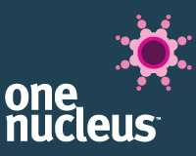
Credit to Tony Jones and his team for putting together such an impressive and insightful panel for this plenary session @One Nucleus:
- "It's pictures that make a good film, the script is important, but if you want a point to resonate, you need to back it up with pictures"- Richard Westcott, BBC Look East

- "Be authentic, clear and structured with your stories"- Steve Palmer, Director of Communications, Sanger

- "Change the focus of the story for the audience you want to reach"- SP

- "Focus on the impact of what you are trying to do. What are the outcomes, not the process"- Sabine Jaccaud, Director of Corporate Affairs, Astra Zeneca

- "Be very clear when distributing your story where you want to make the impact and, equally importantly, where you don't!"- SJ

- "Personalise the big message"- SJ

- "Contemplate how to reach the few with impact whilst engaging the many for credibility"- SJ

- "Don't patronise. Don't jargonise."- Mike Scialom, Journalist, Cambridge Independent

- "Be as open as you dare with your business model and your technology"- MS

- "Embrace the power of video- use it to tell your story in an engaging way."- Andy Rice, Director of Business Development

